ENTER SHORT TAGLINE THAT SAYS WHAT THE BUSINESS DOES

ADD IMAGE THAT CAPTURERS SERVICE OR BRAND OF BUSINESS (NOT LOGO)

Prepared by:
Date:
Confidentiality: All details of this Business Plan are to be kept strictly private and confidential,

Table of Contents

- Executive Summary
- Company Description
Products and services
Long-term Aim of Business
Why Jersey
S.W.O.T. Analysis
- Market Analysis
Target Market
Profile of Competitors
Your Competitive Advantage
- Marketing and Sales Strategy
Marketing Strategy
Sales Strategy
Pricing Strategy
- Management Team
Executive Summary & Career Highlights
Staffing
Training Plans
Recruitment
- Salary and Local Tax Contributions
- Financial Projection and Forecasting
- Appendices

EXECUTIVE SUMMARY
You should complete this section after you’ve written the rest of the business plan. Here you should highlight all the key messages from the rest of the document and sum up the following areas:
- Purpose of the plan
- Product or service and its advantages
- Market opportunity
- Management team
- Track record, if any
- Financial projections
- Funding requirements

If you are looking for external funding remember that potential investors often make an initial judgement based on the executive summary so their decision to read the main body of the business plan will depend on the information presented here. Use appendices at the back of the plan for more detailed information to support the main text of the business plan.

2. COMPANY DESCRIPTION

Describe the people involved in starting the business:
- Financial backers
- Company structure and areas of responsibility
- Shareholders names, no. of shares, % shareholding and cash investment to date (if applicable)

Products and Services Provided by BUSINESS NAME
Detail what your primary services and product portfolio is in detail.

Long-Term Aim of the Business
Describe your long-term aim for the business. Detail what value it adds to Jersey and

Why Jersey
Break your long-term aim down into specific milestones to be achieved by the company over the period of the business plan.
This must also include Corporate and Social Responsibility activities for Jersey and export/economic impact of your business succeeding in Jersey. Think about what Jersey has to offer the business and how you can contribute to the local market, community and other services locally.

SWOT Analysis
Including a SWOT analysis is a simple way of illustrating the strengths and weaknesses of the business and product or service, the opportunities that exist in the marketplace, and the threats to the viability of the project. Complete the SWOT template below or Download a SWOT template separately.

S.W.O.T. Analysis Template
List each of your business's strengths, weaknesses, opportunities or threats in the table below remember that some strengths may also be weaknesses and some opportunities may also be threats.

Strengths | Weaknesses
eg. Cutting-edge technology | eg. One dominant customer
Opportunities | Threats
eg. New overseas market | eg. Larger competitor reducing prices

3. MARKET ANALYSIS
This section covers market research and competitor analysis. You must show that you understand your marketplace and that there is a viable market for your product or service. This will also justify the sales projections made in your financial projections.

Target Market
Describe the market to which you are planning to sell your product or service. You might want to break your market down into different segments describing their relative size and characteristics.

You should estimate the value of your market segments so you can estimate your potential for sales. It is also important to understand what is happening in these segments if, for example, they are growing or declining. You can then adjust your plan to reflect your response to these trends.

Profile of Competitors
You need to know who your competitors are in your marketplace. You should illustrate who they are and where they are, what they sell and what their unique selling point is.

4. MARKETING AND SALES PLAN
Now you’ve explained your market you need to describe your strategies for reaching your target market.

Marketing Plan
Your marketing plan must describe in detail how you will position your product or service in the market and differentiate it from its competitors. You should set out:
- Your marketing objectives which usually reflect your overall business objectives
- Your brand positioning in the marketplace. You should be able to describe your positioning in terms of one or more of:
- Unique product features
- Added value to the customer.
- Price positioning
- As a driver of efficiency
- Greater compatibility with existing systems
- Include any independent validation or case studies.
- How you will set the price charged for your product or service. This must match up with the figures in your financial projections. You will want to consider:
- Competitors’ prices
- Level of competition in the market
- Perception of quality-price relationship by customers
- Production costs and overheads
- How you will promote your product to your key market segments. You might want to use one or more of the following:
  - Advertising – where, when, how, to whom
  - Public relations
  - Direct marketing
  - Website and internet marketing
  - Exhibitions and conferences
  - Word of mouth
- The resources you have to undertake your marketing
- If appropriate you will also make reference to:
- Potential customers have you already targeted
- Any product or site testing you have already undertaken

Sales Plan
Your Sales Plan will describe how you will sell your product or service to the target market. You might use one or more of the following routes to market but for each, you need to explain the advantages and practicalities of developing them and how they will deliver sales:
- Directly
- Retail
- Distributor
- Agent
- Sales rep
- Website

Operations
You need to think about how you will operate your business. What you will need in terms of infrastructure to manufacture or deliver your product or service. You should consider:
- Premises
- Plant and equipment
- Production processes
- IT requirements
- Transport and delivery
- Suppliers
- Insurance
- Licences and regulatory/compliance obligations
- Environmental impact

RISK ANALYSIS
It is good practice to show that you have reviewed the risks that could affect your business and its likelihood of success. You should also indicate how you will review and mitigate these risks should they actually occur. Risks can include such things as:
- The impact of competitor action on your business
- Commercial issues such as an increase or decrease in sales, raw material prices or deliveries
- Operational issues relating to IT or production failure
- Staff including skills, availability and cost
- External issues such as changes in regulation, environmental or political changes

You may find it beneficial to use a business assessment tool such as a PEST analysis looking at the political, economic, social and technological external factors which may affect your business.

5. MANAGEMENT AND STAFFING

Executive Summary and Career Highlights
Describe the team of people who will be responsible for managing the business, their experience and expertise. You will need to consider how the key areas of your business will be structured. You might also need to explain how the management team will increase or change as the business grows.

- Name:
- Date of Birth:
- Nationality:
- LinkedIn:
- Curriculum Vita: see appendix XX
- Qualifications/Education: degree or higher.

Staffing
Explain how and in what areas your employee numbers will grow as your business expands. You should relate this to the skills and positions you will need rather than to individual people. It might be useful to include an organisation chart in this section.

Training Plans
Outline the planned employee and management development to be undertaken in order to maintain a skilled workforce. This should also tie in with the future market developments and any new product or service developments.

Recruitment
Outline any planned recruitment activity including your policy and process for taking on new staff.

6. Jersey Tax Contributions and Gross Value Add (GVA)

Add High Value Tax and GVA Tabel

Below is a full summary of local taxes and Gross Value Add (GVA) examples between 2024 to 2027.

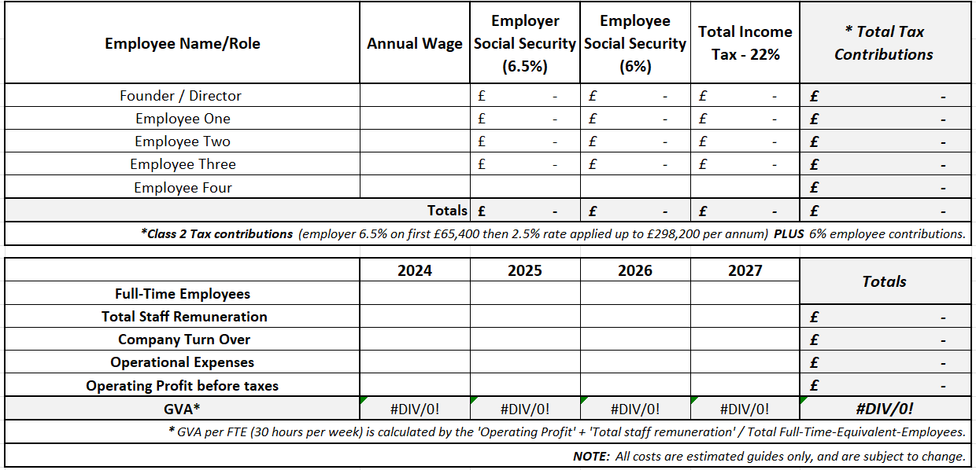

2024
Business Name will start trading in Jersey on DATE (subject to Business Licence approval). The financial year will be measured from 1st January until 31st December, meaning 2024 financials are prorated, with 8 months of trading vs 12 months.

- 2024 social security and tax contributions are estimated to be £xx
- 2024 Gross Value Add is estimated to be £xxx

2025
- 2025 Social security and tax contributions are estimated to be £xx
- 2025 Gross Value Add is estimated to be £xx

2026
- 2026 social security and tax contributions are estimated to be £xx
- 2026 Gross Value Add is estimated to be £xx.

2027
- 2027 social security and tax contributions are estimated to be £xx
- 2027 Gross Value Add is estimated to be £xx.

7. FINANCIAL PROJECTIONS & KEY ASSUMPTIONS
You need to set out your key financial projections and outline any assumptions you have used in the reaching them. Your projections should include a cash flow and profit and loss statement so you will need to think about items such as:
- Sources of income
- Number of employees projected for each year and their intended salaries
- Projected investment in equipment and materials
- Expected rent and rates charges
- Creditor days expected and debtor days allowed
- Expenses and overheads

Add full business financial tables.
SEE AND EDIT Operational Cost EXCELL TEMPLATE
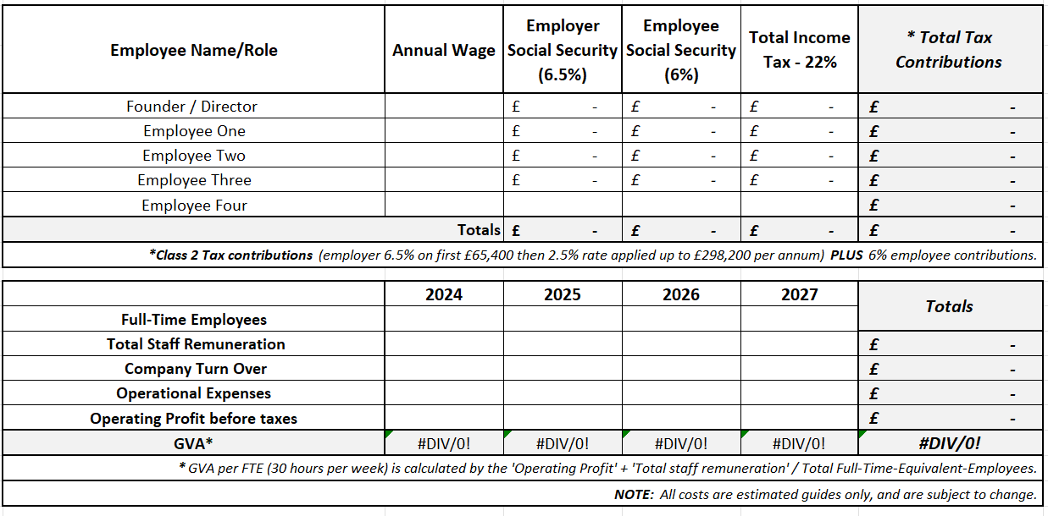

2024

2025

2026

2027

8. APPENDICES
This should include any additional documents that support, or you refer to, in your business plan. This may include:
- Your CV and (if relevant) those of your business partners and/or key employees
- Certificates for relevant training courses
- Copies of a lease for any business premises you will be renting.
Any data of market research that you have done.
- Financial forecast documents – cash flow forecast, profit & loss account (and balance sheet if relevant)
- If your business that is already trading in another jurisdiction, include financial statements for that business including Companies House and other credit referencing agencies.

Appendix One – Company Registration

Appendix Two – Curriculum Vita

Appendix Three – Customer Endorsements or Letters of Commercial Intent etc

